Huỳnh Thanh Dũng 17110016

KNN iris.data

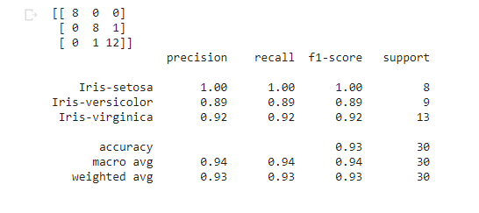

<https://colab.research.google.com/drive/1ZpNJEeDlGiuCdO2Iv2blqqdfWcSOoETe#scrollTo=2rsdd9mJMYqF>

DT iris.data

<https://colab.research.google.com/drive/19F17yEzP3X0NLLFgv24oItKzf75T1AxV>

Randomforest iris.data

<https://colab.research.google.com/drive/1O98v4OiO_df8ZZzNZG8NfcDk8IeQr1xz>

SVM iris.data

<https://colab.research.google.com/drive/1NRLVwRRn9Bhdv9XKTojUX5MP7TIqghvt#scrollTo=ZcLi37y8eUOf>

KNN lung-cancer.data

<https://colab.research.google.com/drive/1JB9Q4PP_2wkF4Rdgy0LJdjLirFbmgCqm#scrollTo=8JymEGKTm6gW>

DT lung-cancer.data

<https://colab.research.google.com/drive/18K_GnKGV2vGTmeRv7S2_I8_UHYdk5ZL8#scrollTo=YjK50ieRpanP>

Randomforest lung-cancer.data

<https://colab.research.google.com/drive/1MNshse4R0bKCIVHovqDnuuSy5L5JFwK-#scrollTo=zK4U9WBbh2Uk>

SVM lung-cancer.data

<https://colab.research.google.com/drive/1tWl4SfhmJCstjQNJ9wj0gtRMYMl91Gp4>